My time in America was truly amazing! I did my internship at the De Witte laboratory at the Icahn school of Medicine at the Mount Sinai Hospital in New York City. I worked with cerebral organoids that were incorporated with microglia, a new model system. In addition, I learned techniques as cryostat, immunohistochemistry, confocal microscopy, and RT qPCR. Additionally, the Mount Sinai Hospital is located right next to Central Park so my everyday view outside the window was beautiful. I learned a lot during my internship and I am very grateful I was given this opportunity.
Living in New York, everyday felt like an adventure to explore a new world. With so many people and cultures coming together in one city, every neighborhood had something unique. I have never been much of a cultural lover, but all of the beautiful museums and theater shows that I visited have completely changed this for me. I also have some newly found appreciation for the Dutch culture and look forward to exploring the rich art culture and architecture our own country has to offer.
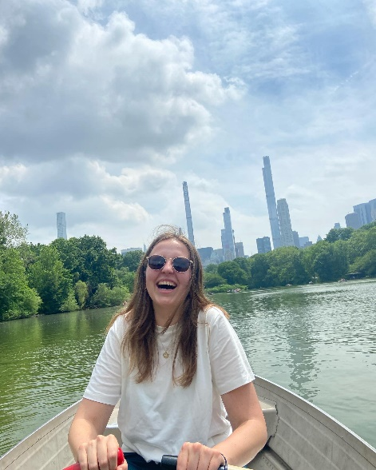
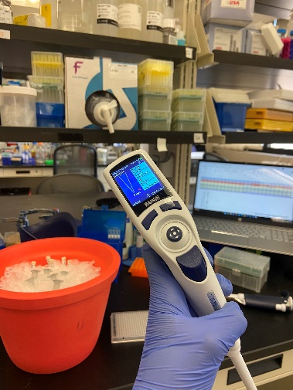
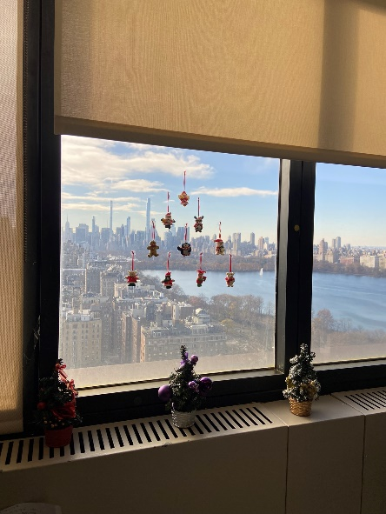
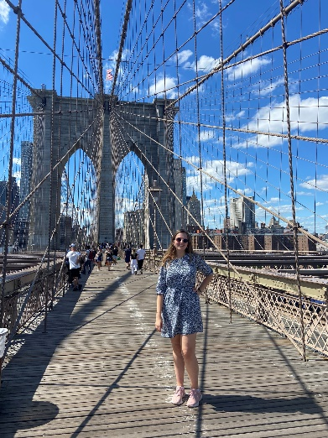
All in all, I have an incredible period to look back to, full of educational and fun experiences. I want to thank the Nora Baart Foundation for their support, I feel very grateful.

