Melbourne 2020
Klasina Chappin
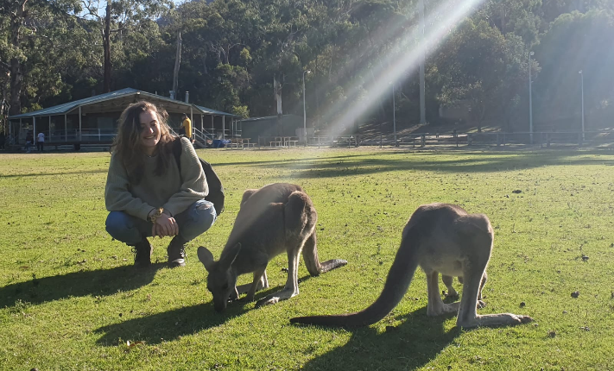
I was lucky to be one of the few persons that could continue working during the lockdown in Melbourne during the SARS-CoV-2 pandemic. My internship was in the lab of Professor Mark Hogarth which develops therapeutic antibodies as a treatment strategy for several diseases, including cancer. During the pandemic the group worked on corona-related proteins, hence we were able to continue our research during lockdown. However, the work floor were quite empty during this period and there were very few students around. Luckily, my colleagues were the kindest and most helpful people and made my internship a great success. Due to the small size of the group and the appreciation I got for what I did I felt really part of the team and involved in the project. My professor was very approachable and I could always walk into his office for a question or a simple chat. After finishing up I continued working as a research assistant for a few months until boarders were opening up again and I was able to travel.

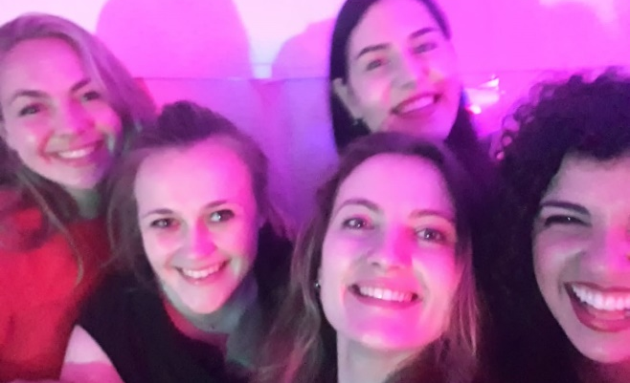
Life outside the lab was a bit different that I am used to and from pre-pandemic times when I arrived in Australia. In Melbourne we have been in a long lockdown, in which restaurant/bars have been closed for months and there was an evening curfew and we were allowed to be only in a radius of a few km from our homes. This made it all a very interesting experience and of course had a serious impact on my social life as well as on hobbies and sports I like to do. However, the people that I met made me feel at home and my colleagues were there to help me out if needed. Besides, on the moment of writing this I am traveling to explore the beaty of Australia as things are opening up again!
I am very happy to finish my masters and thankful to get the chance to do my internship in this city, as well as the financial support that made this possible. I would definitely recommend Melbourne as a great city to do an internship, as there are plenty of internationals here and numerous parks, cafes and restaurants to visit. And, of course, the breath-taking nature and exciting places to explore in Australia in your free time!

