Master internship at Harvard Stem Cell Institute, Boston, USA
Audrey Sporrij

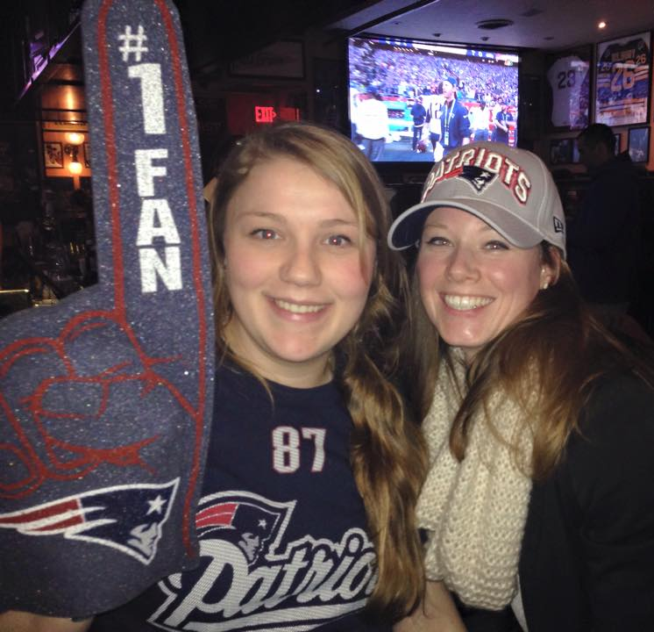
A part of the master Cancer, Stem Cell and Developmental Biology at Utrecht University, I chose to perform an internship at the Harvard Stem Cell Institute/Harvard Medical School in Boston, USA in the lab of prof. LI Zon. This lab focusses on stem cell development in zebrafish. I got the chance to work on a very promising project that aims at the identification of the molecular mechanisms of prostaglandin E2 (PGE2) on hematopoietic stem cells. PGE2 is already in clinical trials based on earlier research from the lab and shows great potential to implement in umbilical cord blood transplantations since it increases both engraftment of stem cells and long-term hematopoiesis in patients. Therefore, I was super excited to work on this project. The lab was simply amazing. Prof. Zon is not only a great scientist but also a wonderful person and amazing mentor. I got the opportunity to work with a very talented post-doc who teached me all I needed to know and gave me full lead over my part of the project. As important as the science is, social interaction of course play a big role in making my stay in Boston such a great experience. Although it is a huge lab counting over 50 people, it soon feels like you're a part of a very special family. The atmosphere in the lab was great. Memorable events like our lab ski retreat, cocktail evenings, barbeques and home made birthday cakes as well as the data & coffee meetings with my supervisor will not easily be forgotten.

Outside of work, I met a great bunch of people and got the opportunity to do a lot of fun activities with them. With friends, I joined a salsa course, went snowboarding near the Canadian border, sailing and canoeing on the Charles River, explored all the restaurants in Boston and drank a lot of coffee! Oh, and guess who won the superbowl this year! I also got the opportunity to do some travelling which took me to Washington, New York, Cape Cod & Nantucket.

I left the Netherlands in January 2015 and although I had lived abroad before, this was my first time in the States. It took a couple of weeks to find out how this country 'works'. Although you speak the language, simple things like biking are a challenge here especially if you don't want to get killed. The winter in Boston this year was brutal but with spring coming into town, the snow vanished and temperatures quickly turned to 30*C, which is where it stayed from May until August. With the weather getting a little more bearable, we made good use of all the parks and riverbanks.

This experience has brought me more than I could have wished for. The science at Harvard definitely lives up to the expectations. I would not have wanted to miss working in such a motivating and rewarding environment. The people in the lab have become family and the great friends and memories I made will be cherished. It was an amazing experience!

Herewith, I would like to thank the Nora Baart Foundation for their support and making this international internship possible.

