Reisverslag Nora Baart Student Sarah Weischer
Master Internship about STAT1 nucleocytoplasmic shuttling in the lab of Thorsten Mempel, Center for Immunology and Inflammatory Diseases, Massachusetts General Hospital, Boston, USA

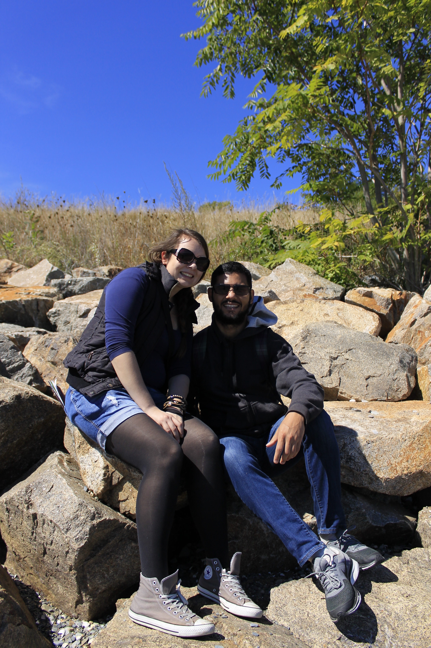When I arrived at the Boston Logan Airport at a snowy and cold night in January. I checked in a nice hotel close to my workplace. On the next morning I had my first lab meeting. I met my supervisor and all other lab members and the atmosphere during the lab meeting seemed pretty relaxed. That was a good sign. During the first weekend I was looking for a place to stay. I found a very nice apartment in the heart of Cambridge and could move in the following Monday. The only drawback: it was unfurnished. Another two weeks of finding furniture for my small student budget followed and finally I could say: I arrived in Boston. Let the fun begin!
I enjoyed my time in Boston and tried to travel as much as possible – Cape Cod, the Boston Harbor Islands, New York City, Philadelphia, Washington DC and Chicago. However, the rumor about working “24/7” in the US is true, at least true for my lab. It didn’t matter when I arrived in the lab, someone was already there. Whereas at the RIMLS in Nijmegen a new student is taken by the hand for the first weeks and introduced to every single reagent and technique, at the MGH they say: “We offer you all opportunities, it depends on you what to do with it”. They don’t grant you any credit in advance for your motivation and previous work. You will be what you earn yourself. Being confronted with this attitude made some things very clear to me. First of all, I am very happy that I decided to perform my PhD in the Netherlands. And secondly, I realized that I don’t want to be a ‘competitor’ in the Harvard environment only working to achieve my personal goals. I want to do good science, work in a team and enjoy my work because we do research to unravel the mechanisms of disease and in the very end to help patients with our knowledge. During my time in Boston, I sometimes thought that I should put this very ‘naïve’ and optimistic view aside and start being competitive, but now looking back I am very happy that I didn’t.
I was lucky that I found very good friends in Boston with which I will hopefully have life-long contact. They helped me a lot to get through the struggles in the lab and the other problems you encounter when you live abroad. I have a lots of good memories about my stay in the US, but saying that everything was fun would be a lie. It was tough, but I am happy and also a little bit proud that I made it through all these problems and now look back on it and say: “It was worth it”.

