From January 2023 to September 2023 I completed an internship in the Malaria Virulence and Drug Discovery Group at the Burnet Institute in Melbourne, Australia. During this time, I worked on investigating the assembly of the protein export machine PTEX and its role in haemoglobin digestion and artemisinin resistance in Plasmodium falciparum. PTEX is an essential protein complex with functions that go well beyond simply exporting proteins, many of which are not well characterized. By understanding the essential proteins and processes in the blood stages of malaria parasites we hope to be able to target them in novel drug design. I had an incredible experience at the lab, which was a very collaborative and supportive environment ideal for learning and growing professionally. It was fascinating to learn a variety of new techniques like malaria cell culture, growth assays, and ring survival assays. In addition to the lab work, the institute offered a great variety of seminars and workshops to foster professional development, even giving me the opportunity to present my research at the Australian Society for Parasitology’s Annual Conference in Darwin.

Outside of the lab I had the opportunity to enjoy the vibrant city life Melbourne has to offer as well as travel around Australia. In Melbourne, I enjoyed visiting the large variety of museums, attending local sporting games, and visiting the many rooftop bars Melbourne is known for. Beyond that I had the opportunity to visit Tasmania, Sydney, and Cairns to get a better idea of the vastness of the country. Aside from the beautiful country I also met the most incredible people both inside and out of the lab that really made it an experience that I will cherish forever.

I would like to thank the Nora Baart Foundation for awarding me the grant that helped me realize my dream of going abroad to study in Australia: an incredible experience of both personal and professional growth. I am excited to see where my career will go from here.

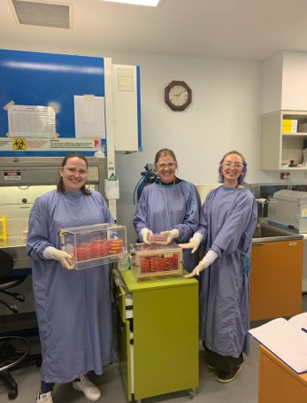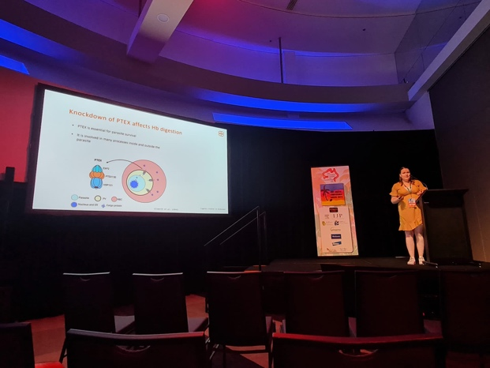
Top left: Culturing parasites in the lab

Top right: Presenting my research at the ASP annual conference

Bottom left: Hiking in Cradle Mountain, Tasmania

Bottom right: Wildlife sanctuary on the Mornington Peninsula
