Internship at the Peter Doherty Institute in Melbourne
February – July 2020
Marieke Nühn

One thing on top of my bucket list was to live and study a few months abroad. Therefore, I was extremely grateful that the Peter Doherty Institute for Infection and Immunity gave me the opportunity to perform a 6-months internship for my Master program in Melbourne. I joined the lab of Sharon Lewin, which is specialized in HIV research. My internship was focused on the development of a cell-line which carried an HIV-like construct integrated at a location mimicking an integration site observed in individuals living with HIV. This cell-line will be used to provide more knowledge on the behavior of the HIV-virus. This was a challenging and interesting experiment to work on during my stay in Melbourne.

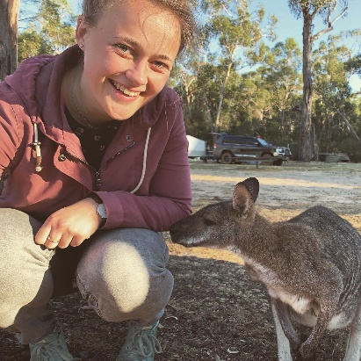
My arrival in Melbourne was great and I felt very welcome. In February it is summer in Australia, so the weather was really nice. My roommates were all international students and made me feel home really quick. Moreover, the people within the lab were really friendly . The environment stimulated me to work independently but people were always willing to help. Unfortunately, I had to leave Melbourne after 2 months because of the COVID-19 pandemic. My lab closed and the Utrecht university strongly advised me to return home to The Netherlands. Luckily, my supervisors in Melbourne and Utrecht were really flexible and together we were able to make the last 4 months of my internship still very fruitful. I wrote a grant proposal that already has been submitted, and a literature review that probably will be published in future. Although the internship went not as I planned on forehand, I still learned to work within a completely different environment with a different language and I gained a lot of practical and academic skills.

Luckily, during my stay 2 months stay in Melbourne I still had the opportunity to get to know Melbourne better. Melbourne is a really young and cheerful city because of the many pubs, art and lovely people. Moreover, the surrounding of Melbourne is wonderful. After an one hour drive, you are already in beautiful nature which is completely different from the city. Together with my room mates, I drove the Great Ocean Road, and I did a fantastic camping trip together with the people from my lab. Altogether, my stay in Melbourne was a fantastic experience that I didn’t want to miss. I sincerely thank the Nora-Baart Foundation for their financial support that made this possible!
